APPENDIX 1 – Site Block Plan

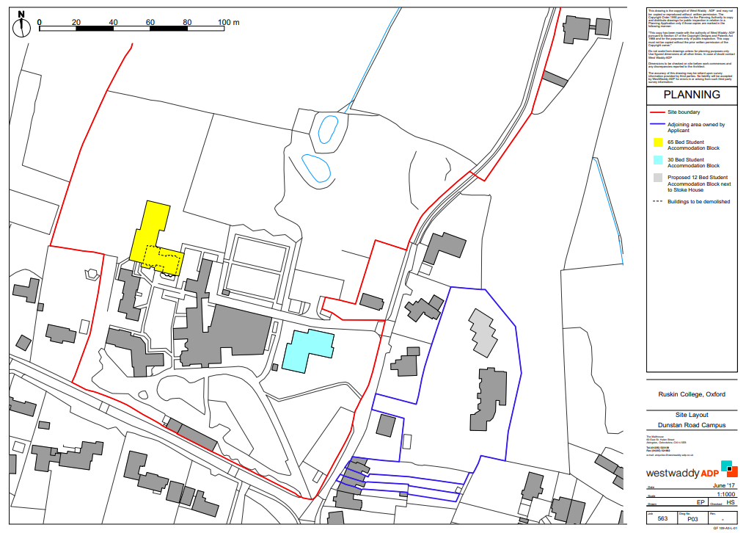
Ruskin Hall
Campus
65 bed block
Stoke House
Campus
30 Bed Block

